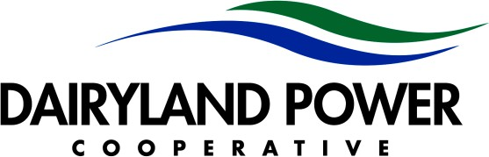

|  |
| --- |
| **2025 Board Meeting Dates** |
| **January 22-23** |
| **February 10-12 District Meetings** |
| **March 19-20** |
| **April 16-17** |
| **May 14-15** |
| **June 4 Annual Meeting (Board reorganizational meeting to follow)** |
| **June 25 Board Education** |
| **July 16-17** |
| **August 20-21** |
| **September 18** |
| **October 15-16** |
| **November 19-20** |
| **December 17-18** |
|  |
| **2026 Board Meeting Dates** |
| **January 21-22** |
| **February 9-11 District Meetings** |
| **March 19-20** |
| **April 15-16** |
| **May 13-14** |
| **June 2 Annual Meeting (Board reorganizational meeting to follow)** |
| **June 18 Board Education** |
| **July 15-16** |
| **August 19-20** |
| **September 17** |
| **October 21-22** |
| **November 18-19** |
| **December 16-17** |



3200 East Ave. S. • PO Box 817 • La Crosse, WI 54602-0817 • 608-788-4000 • 608-787-1420 fax • [www.dairylandpower.com](http://www.dairylandpower.com/) Dairyland Power Cooperative is an equal opportunity provider and employer.